# AI Assignment 4

## William Scott – MT18026

**Assumptions:**

* Termination condition is assumed to be “similarity of path taken by all the ants”
* The count of ants is taken as twice the count of cities, by default
* Other than these, ACO is implement as per the algorithm
* Alpha is the influence on pheromone level
* Beta is the influence of favorability of distance

**Methodology:**

* We initialize the cities at random coordinates and generate a distance matrix, which basically tells us the distance of a city with each other cities
* Now, we just have nodes on the graph which are waiting to be connected
* Here, connection refers to an ant choosing that edge during its travel
* Now we place the ants in initial city ‘zero’
  + We tell the ant to take all the paths that are not visited and return back
  + During the travel we store the total distance travelled and the path taken by the ant
  + We do this loop for all ants
  + During this process the ant will be depositing some amount of phenome in the path which will help the other ants to choose a path when multiple paths are available
  + And choosing of a city is done according to a probability which has a calculated amount of pheromone and the distance
* We have a pheromone evaporation level which tells us how much f the pheromone is evaporated during each iteration
* At a certain point all the ants will be taking the same path, this is considered as convergence
* The ants tend to find the shortest path with the probability selection of path on the pheromone

**Algorithm:**

* Generate cities and ants
* Place ants in the initial city
* Repeat until convergence: (all ants take same path)
  + For every ant:
    - Repeat until a unvisited city exits:
      * Choose next city with the conditional pheromone probability
      * Store the path
    - Go back to the initial city
  + Update pheromone level

**Observations:**

* Though the ants are legally blind, they tend to choose the shortest path after certain iterations with the help of pheromone
* The combined ensemble approach of ants helps in finding the shortest distance
* The parameters alpha, beta, no of ants and the number of cities play a huge role
* Alpha >1 and beta > 0. These conditions are so that the formulation of probability doesn’t get invalid.
* With basic alpha 1 and beta 1, the number of iterations are high
* With alpha 2, and beta 2, the number of iterations gets reduced
* With alpha > beta the ants seem to choose paths that are even longer
* With beta > alpha the ants seem to choose the shorter path helping to converge sooner.
* With increase in number of cities, more computation power is needed, taking more time to converge
* Increasing the number of ants will increase the computational capacity but can give a better result

**Results:**

|  |  |  |  |  |  |  |
| --- | --- | --- | --- | --- | --- | --- |
| No of Cities | No of Ants | Pheromone Evaporation Level | Alpha | Beta | Iterations | Time (sec) |
| 30 | 90 | 0.5 | 4 | 6 | 5 | 14 |
| 30 | 90 | 0.5 | 4 | 6 | 6 | 18 |
| 30 | 150 | 0.5 | 4 | 6 | 6 | 29 |
| 30 | 90 | 0.1 | 4 | 6 | 12 | 36 |
| 30 | 90 | 0.9 | 4 | 6 | 6 | 23 |
| 30 | 90 | 0.5 | 1 | 1 | 50+ | 180+ |
| 30 | 90 | 0.5 | 6 | 4 | 5 | 14 |
| 30 | 90 | 0.5 | 2 | 2 | 13 | 44 |
| 30 | 90 | 0.1 | 2 | 2 | 13 | 44 |
| 30 | 90 | 0.5 | 6 | 4 | 24 | 66 |
| 30 | 90 | 0.9 | 6 | 4 | 5 | 16 |
| 30 | 15 | 0.9 | 6 | 4 | 7 | 3 |
| 30 | 15 | 0.5 | 6 | 4 | 5 | 2 |
| 30 | 15 | 0.1 | 6 | 4 | 7 | 4 |
| 30 | 15 | 0.1 | 4 | 6 | 7 | 4 |

**Result 1:**

Cities: 30

Ants: 60

Iterations: 5

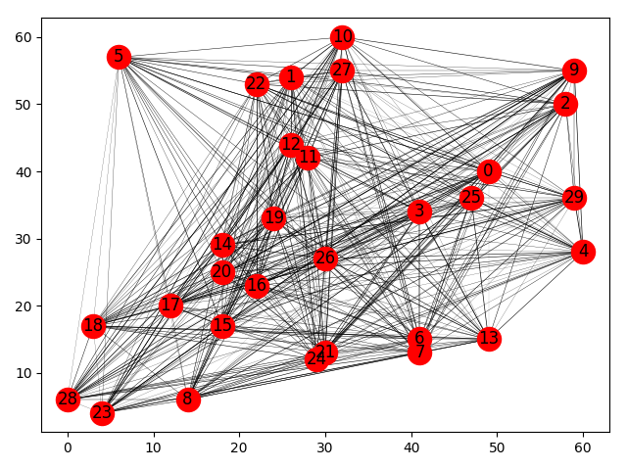

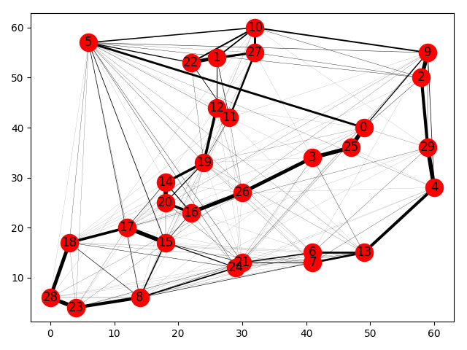

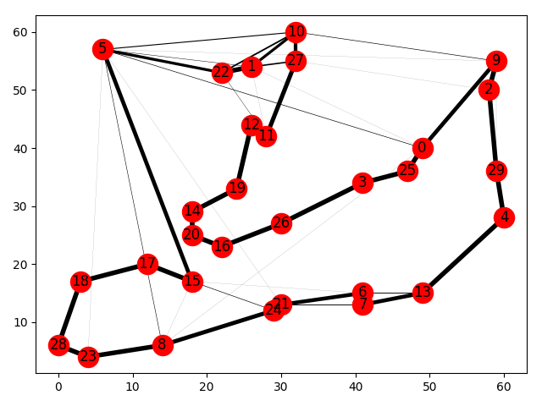

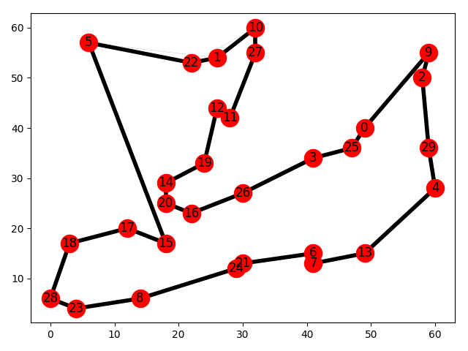

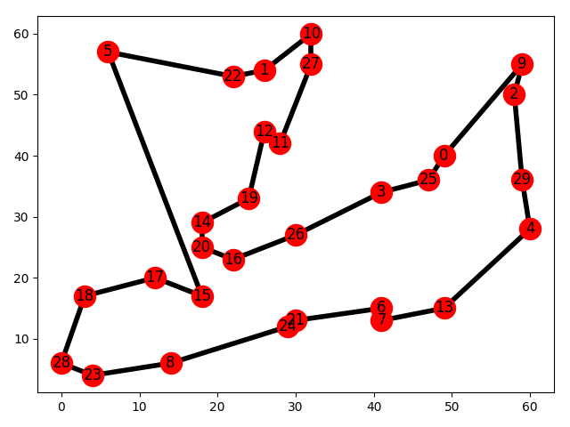

**Result 2:**

Cities: 30

Ants: 60

Iterations: 6

